Low power indication improvement script - Preliminary

Introduction
During our continuous test we noticed that the low power indication in the TEAMS-M15 headset setting is not optimized and arrives sooner than expected
User can get low power indication after around 6-7 hours (pending the operation) while the headset will continue to work at least 5-6 hours more before shutdown.
The low power indication should arrive few hours before shutdown to remind user to charge the unit.
This optimized setting will be updated on the next production, however we created this script to update the low power indication setting for units in the field.

Low power indication improvement script

    - Setting

      - The script should work on Windows based laptop (Windows 10)
      - Please ensure you have Midland Configuration Tool or admin tool on your laptop
      - Please save the “Pro pskey tool – low power 347_354_378” zip on your desktop and extract the folder.

Low power indication improvement script operation

- Connect headset to the laptop using USB-C to USB-A cable
- Open the folder
- Double click “CLICK-HERE” to active the script

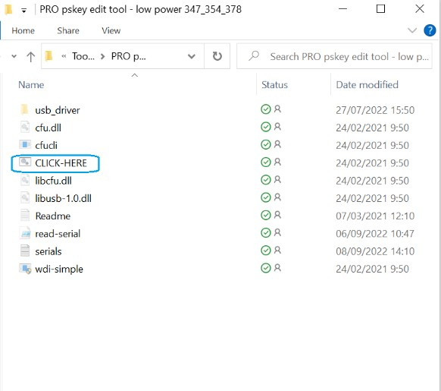

- Screen will be open for short time ensure not to have red text inside, if there is red text check your USB cable to confirm that the unit is connected
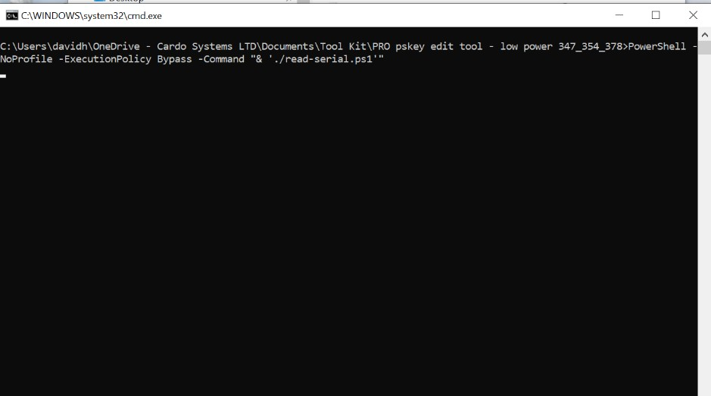

- You can confirm that the script was activated on this unit by checking the headset serial number on the serials file
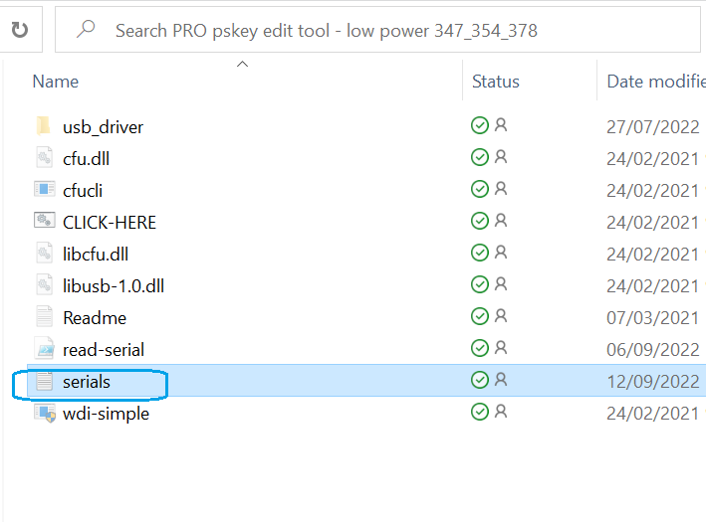
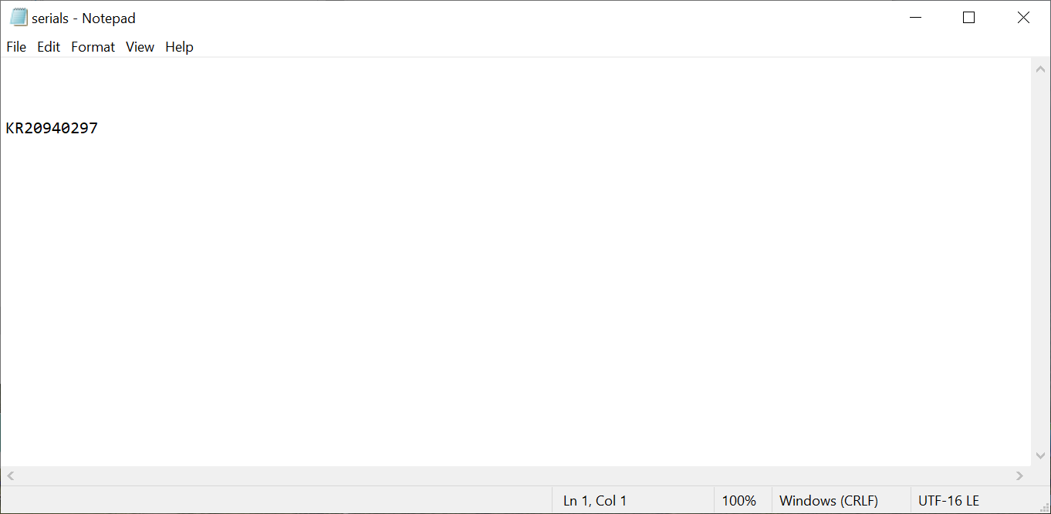

- Connect the next headset and repeat this process
- We recommend to active this script on the units you have before sending to the field

Thank you

